**Customizations and features**

1. **Feature 1: Home page**

|  |  |
| --- | --- |
| **ID** | 001 |
| **Actors** | Alumni, Alumni pathways |
| **Description** | The homepage serves as the central hub of your digital experience, combining intuitive navigation with visually engaging content.   * Application home screen contains two options * Have you completed matriculation?   + How to apply for intermediate colleges?   + Do you want to avail a scholarship from TCF? * Are you currently pursuing intermediate? |
| **Pre-Condition(s)** | * The app must be installed on a compatible mobile device. * The homepage should dynamically adjust based on user preferences or settings. * If the homepage fetches dynamic content, an internet connection (Wi-Fi or mobile data) should be available. |
| **Success Post-Condition(s)** | * The page is free of broken links or missing assets (images, icons, scripts) * The homepage renders seamlessly on all devices * The homepage loads in under 3 seconds, even during high traffic. |
| **Failure Post-Condition(s)** | * Broken links, missing images, or script errors occur on the homepage. * Elements like buttons, forms, or sliders are non-functional or improperly rendered on mobile devices. * Users complain about the layout, content, or difficulty in accessing what they need. |

* 1. **Screen:**

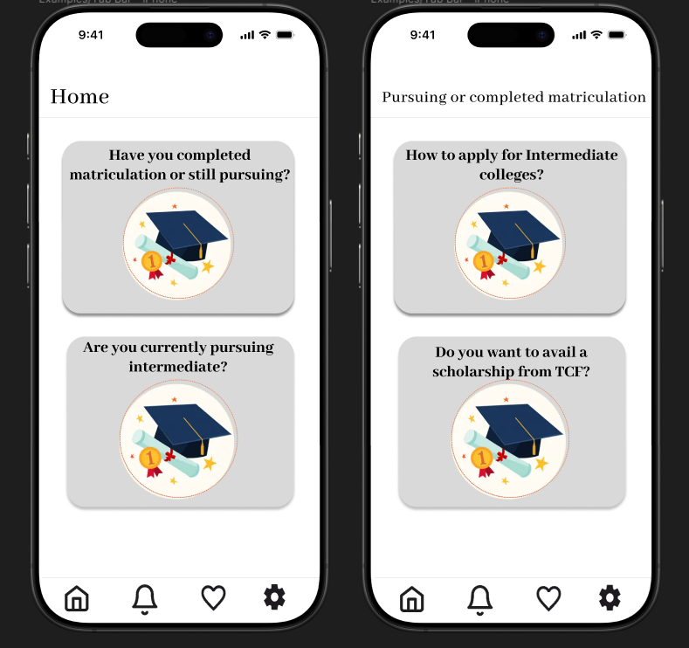

1. **Feature 2: Guidance for Intermediate page**

|  |  |
| --- | --- |
| **ID** | 002 |
| **Actors** | Alumni, Alumni pathways |
| **Description** | This page consists of two options   * How to apply?   + Resources page * Where to apply?   + Nearest institutes |
| **Pre-Condition(s)** | * Links to relevant pages should be properly attached and display information as per location and institute settings. |
| **Success Post-Condition(s)** | * On Clicking the links should open relevant pages linked. |
| **Failure Post-Condition(s)** | * Broken links, missing images, or script errors occur on the page. * Elements like buttons, forms, or sliders are non-functional or improperly rendered on mobile devices. * Users complain about the layout, content, or difficulty in accessing what they need. |

* 1. **Screens:**

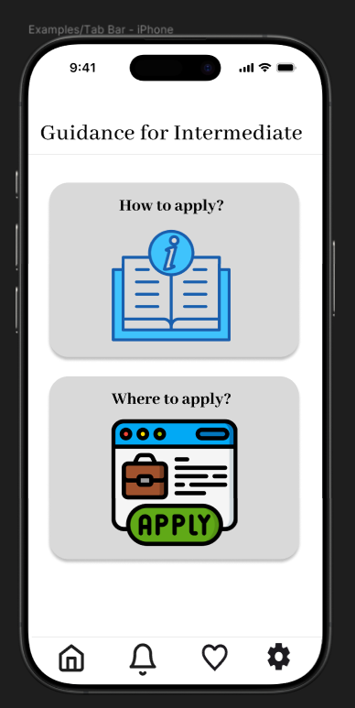

1. **Feature 3: Resources page**

|  |  |
| --- | --- |
| **ID** | 003 |
| **Actors** | Alumni, Alumni pathways |
| **Description** | Resources page will display relevant resources and links of the guidance documents and videos |
| **Pre-Condition(s)** | Ensure all attachments and links are attached. |
| **Success Post-Condition(s)** | User will be redirected to the attachments, forms and links successfully |
| **Failure Post-Condition(s)** | * Broken links, missing images, or script errors occur on the page. * Elements like buttons, forms, or sliders are non-functional or improperly rendered on mobile devices. |

* 1. **Screen:**

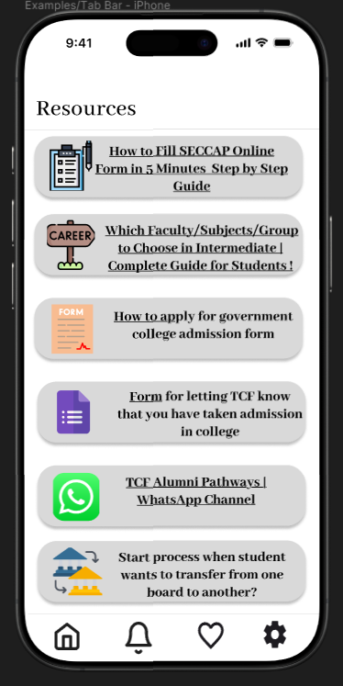

1. **Feature 4: Settings page:**

|  |  |
| --- | --- |
| **ID** | 004 |
| **Actors** | Alumni, Alumni pathways |
| **Description** | Settings page will allow user to filter institutes based on following two parameters   * Nearby radius in kms * Institute performance in % |
| **Pre-Condition(s)** | Maximum and minimum criteria range of location and institute performance should be set |
| **Success Post-Condition(s)** | Nearby institutes will be displayed as per the filtered |
| **Failure Post-Condition(s)** | * Institutes will not be displayed as per filtered. |

* 1. **Screen:**

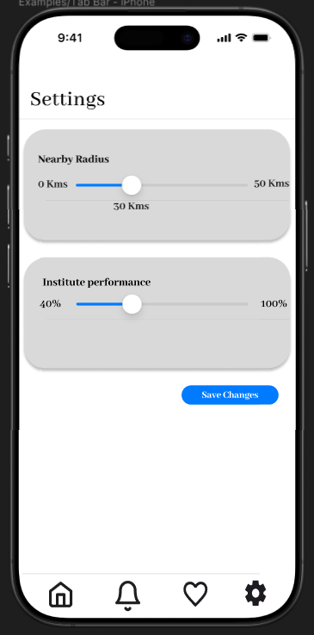

1. **Feature 5: Nearest Institutes, Place details and favorites page**

|  |  |
| --- | --- |
| **ID** | 005 |
| **Actors** | Alumni, Alumni pathways |
| **Description** | Nearest location page will allow users to locate the nearest educational institutes including TCF schools and college, partnered universities, coaching centers and vocational institutes via google maps. |
| **Pre-Condition(s)** | * All nearest institutes should be displayed as per filters set by the user in the settings * Ensure all partnered institutes are properly mapped. |
| **Success Post-Condition(s)** | * On institute tab, user can also mark his favorite institutes which will be saved in favorites pages * On clicking the name of institute ‘place details’ page will be opened basic information about the institutes will be displayed * College attributes   + Institute name   + Managing authority   + Faculty   + Gender   + Admissions criteria * Google maps are integrated from which user will be able to locate partnered institutes nearby. * If user marks some institutes as favorites, it will be displayed in favorites page. * On clicking rate this institute button feedback form will be displayed. |
| **Failure Post-Condition(s)** | * Broken links, missing images, or script errors occur on the homepage. * Elements like buttons, forms, or sliders are non-functional or improperly rendered on mobile devices. * Institutes marked as favorites are not displaying on the favorites page. * Maps are failed to load. * Institutes are not displaying as per filters set by user in the settings. |

**5.1. Screen:**

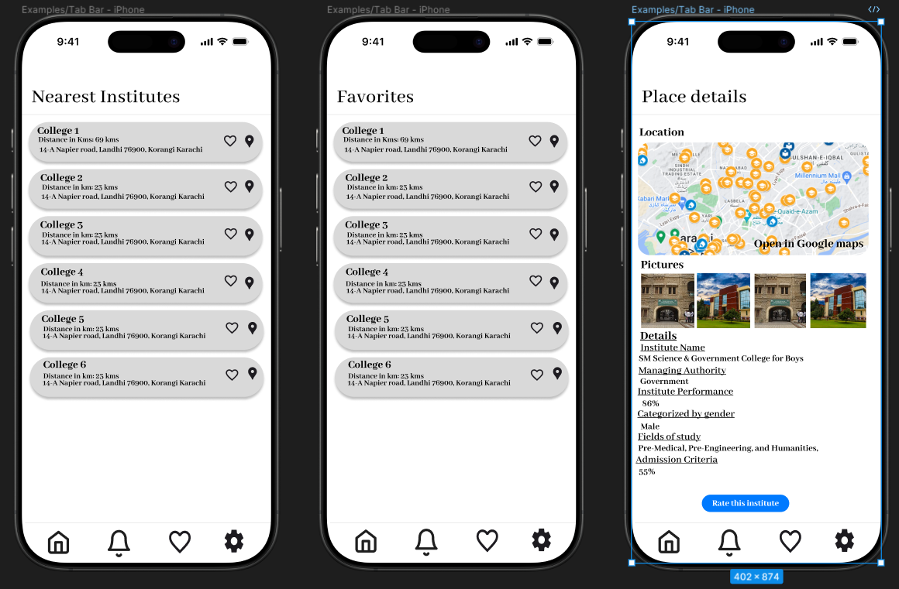

1. **Feedback form:**

|  |  |
| --- | --- |
| **ID** | 006 |
| **Actors** | Alumni, Alumni pathways |
| **Description** | Feedback page consists of google forms in which user will provide his feedback regarding the website.  For feedback form contents and mechanism, please refer |
| **Pre-Condition(s)** | On clicking “Rate this institute” button user will be redirected to feedback form page |
| **Success Post-Condition(s)** | Google form will be integrated in feedback form. |
| **Failure Post-Condition(s)** | * Broken links, missing images, or script errors occur on the mobile application. * Elements like buttons, forms, or sliders are non-functional or improperly rendered on mobile devices. |

* 1. **Screen:**

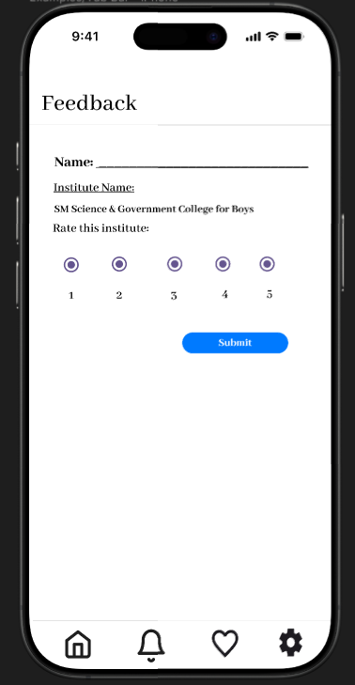

1. **Notifications and Notifications page:**

|  |  |
| --- | --- |
| **ID** | 007 |
| **Actors** | Alumni, Alumni pathways |
| **Description** | Users will be notified with latest announcements regarding admissions and enrollment. |
| **Pre-Condition(s)** | * The app must have the necessary permissions to send notifications * An active internet connection (Wi-Fi or mobile data) is required for receiving push notifications. |
| **Success Post-Condition(s)** | * The notification is successfully delivered to the intended recipient's device. |
| **Failure Post-Condition(s)** | * Users do not receive critical updates or alerts. * The notification contains incorrect or outdated information. |

* 1. **Screen:**

